Required practical activity: Determination of the reacting volume of a vinegar solution by titration with a strong alkali
Required Practical Guide – Vinegar Titration

Aim: To use a burette and colour-changing indicator to find the reacting volume of a vinegar solution
Notes and guidance
You may wish to have students collect the equipment for this themselves from communal trays at the front of the lab. This will help them to develop their skills of equipment recognition and organisation. However, if this is impractical, ask your technician colleagues if they are able to set up individual sets at student workstations. Ensure each group has sufficient space to use a burette comfortably.

It is unsafe to fill a burette above head height. Ensure students move their burette and stand to the floor before filling it.

Students will almost certainly need to practice the technique of slowly opening and closing the burette’s tap as well as using a pipette and pipette filler before conducting the practical. This can be done with distilled water, with the added advantage that this will ensure the equipment is clean.

If students are working in groups, encourage each member of the group to carry out a titration during the lesson.

There are many small mistakes that can lead to inaccurate results. For instance, a funnel left in a burette can drip extra solution into the main reservoir. Students must also take readings from the bottom of the liquid meniscus.

There are a lot of steps to this practical. If your students struggle to follow written instructions, it is advisable to stop the class after each step and deliver instructions for how to proceed. An added advantage of this is that you can add extra theory into your narration and explain why each step is being done.

The aim is to discover the ethanoic (acetic) acid concentration of the vinegar solution. Discuss this experiment with your technician colleague ahead of time. Most shop-bought malt vinegar has a concentration of around 5 % ethanoic (acetic) acid, which is approximately 0.8 mol dm-³.
Risk Assessment Notes
A risk assessment must be completed for this practical. The risk assessment should be specific to the class involved and written only by the teaching member of staff. For more guidance refer to CLEAPSS. It is good practice for students to wear safety spectacles during all class practicals and demos.

Store-bought vinegar – even diluted – can be an irritant. Label appropriately.

0.1 M sodium hydroxide solution is currently classed as an irritant and a cause of skin and eye irritation. Take care while handling it and wear eye protection. For waste disposal, pour down a foul-water drain with plenty of water. Refer to CLEAPSS Hazcard 91.
Equipment Per Group | 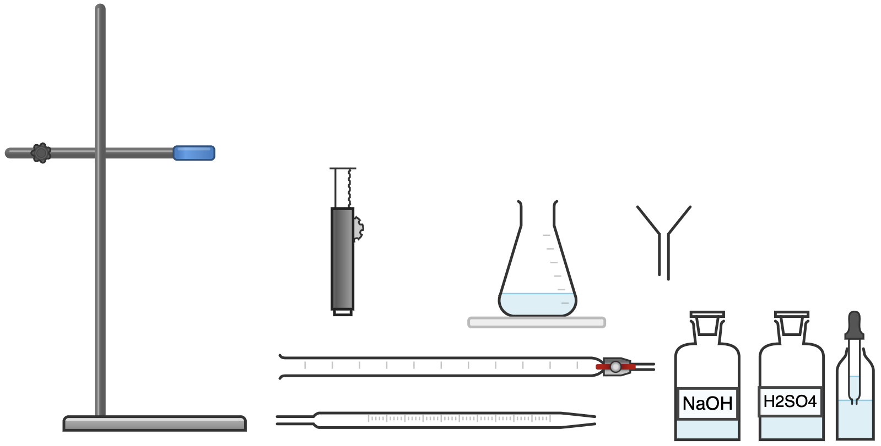  Equipment Per Group  (Phenolphthalein)  VINEGAR
Apparatus:
- 25 cm³ volumetric pipette
- Pipette filler
- 50 cm³ burette
- 250 cm³ conical flask
- Funnel
- Clamp stand and clamp
- White tile

Chemicals:
- 0.1 mol/dm³ sodium hydroxide solution (irritant)
- Vinegar solution (eightfold dilution of store-bought vinegar)
- Phenolphthalein indicator

Method |  | Questions To Ask Students During The Practical
- Clamp the burette to the retort stand with enough space beneath for the conical flask and white tile.  - Check that the burette tap is closed, then use the funnel to help pour in vinegar solution past the 0.00 cm³ line. Remove the funnel.  - Put the bottle of vinegar solution beneath the burette and slowly open the tap until the bottom of the meniscus of the sulfuric acid reaches the 0.00 cm³ line.  - Add 25 cm³ of sodium hydroxide solution to the conical flask using the volumetric pipette and pipette filler.  - Add 5-10 drops of phenolphthalein indicator to the sodium hydroxide in the conical flask. Gently swirl the flask and the contents will turn pink.  - Place the conical flask on a white tile beneath the burette.  - Slowly and carefully open the burette’s tap to allow approximately 10 cm³ of vinegar solution into the conical flask, constantly swirling the conical flask the entire time.  - Close the tap a little so the vinegar solution enters the conical flask a drip at a time. Eventually, one of these drips will cause the colour a colour change from pink to clear. At this point, immediately shut the tap so no more vinegar solution is added.  - Read the level of the sulfuric acid in the burette from the bottom of the meniscus and record this on your table.  - Repeat the experiment two more times and complete your table. Calculate the mean volume of vinegar solution needed to neutralise 25 cm³ of 0.1 mol/dm³ sodium hydroxide. |  | - Why should we move the burette to the floor before filling it? (Pouring solutions above head height is hazardous as a spill or a splash could result in a harmful chemical getting in somebody’s face.)  - Why is it important to remove the funnel from the burette before carrying out the titration? (Extra solution may drip from the funnel into the burette and introduce an error into the results.)  - How do you read the scale of the burette? (Read the scale from the bottom of the meniscus of the liquid.)  - Why do we read the burette in this way? (To ensure consistency between readings and because it is the most accurate reflection of the true level of the liquid [the sides of the meniscus are elevated due to surface tension at the very edge of the liquid].)  - Why do we constantly swirl the conical flask? (To ensure all of the solution has reacted.)  - Why do we use a white tile beneath the conical flask? (To best see the colour change of the solution.)  - Why do we add the solution from the burette slowly? (So as to not miss the exact point at which the solution in the conical flask is neutralised.)  - What colour change does the phenolphthalein indicator exhibit? (It goes from a transparent appearance when neutral or acidic to purple when alkaline.)
Phenolphthalein Indicator Colour Change:
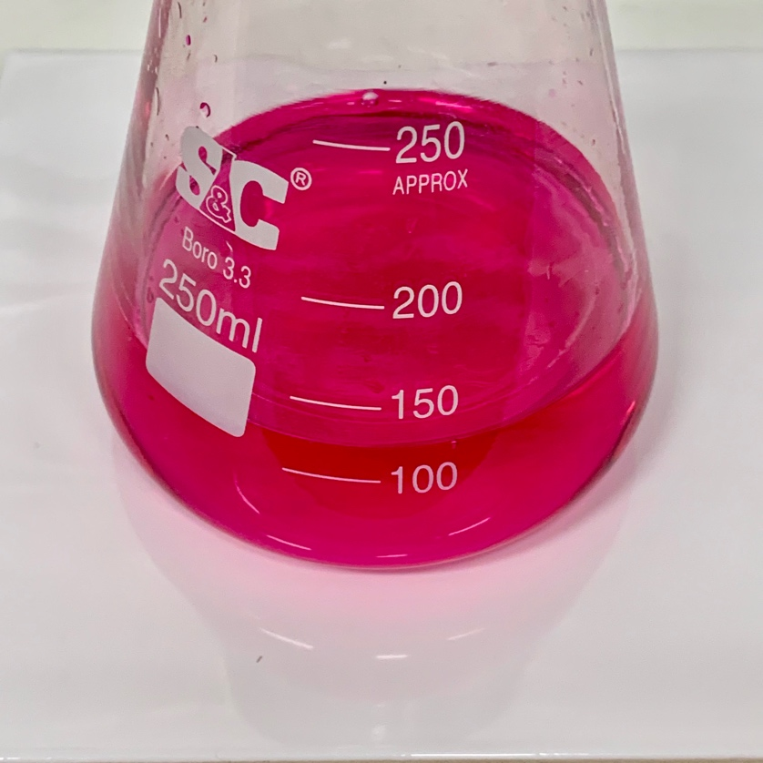
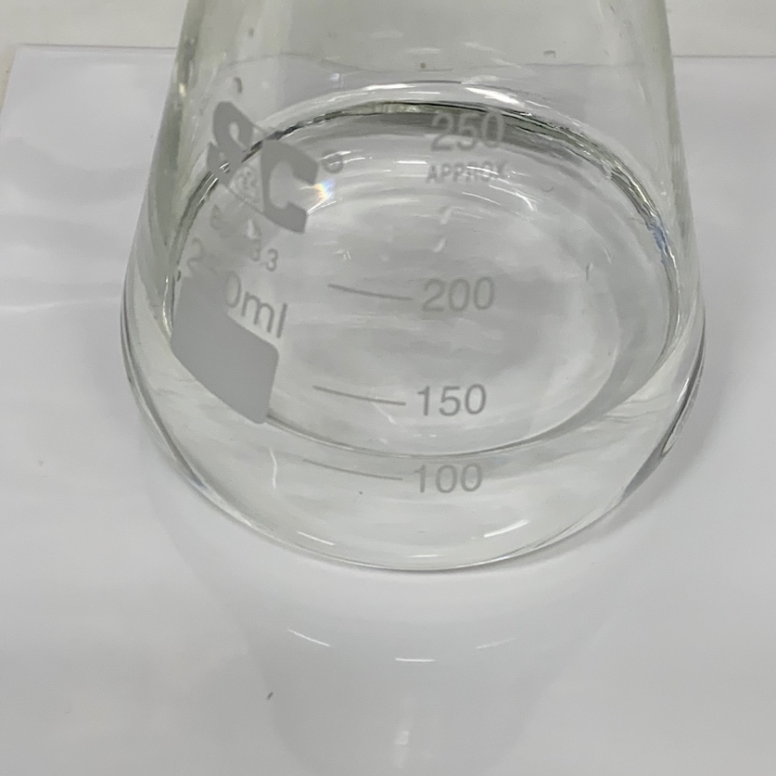

Neutral/Acid
Alkali

Alternative Methods/Computer Simulations |  | Clearing up
If time is available, you may wish to demonstrate this practical with another indicator. Sometimes, an exam question may refer to, for example, methyl orange indicator and if students have only ever seen the pink/transparent phenolphthalein, they may be more likely to get confused.  The acid/base being neutralised can be substituted, but ensure the strengths of the chemicals used are similar so as to not require an excessive volume of either.  The skill of using a burette and volumetric pipette are important for students to learn. However, if these are not available, this experiment can be conducted using two less-than-half-full measuring cylinders of the solutions. First, record the starting volume of the vinegar solution and add the indicator to the sodium hydroxide solution. Then, use a pipette to add vinegar solution to the sodium hydroxide. When the indicator turns clear, squirt any remaining vinegar solution from the pipette back into the measuring cylinder and record how much has been used.  If this method is used, it is still advisable to ensure students know how to use a burette, through a demonstration if possible or a video if not. |  | It is important that equipment is returned to the prep room in good order. If safe to do so, rinse used equipment and put it in the used equipment tray. If the trays arrived on a trolley, students must return all trays and equipment to that trolley. Anything dirty needs to be placed into a separate container for washing up. Never put dirty equipment back into a tray with clean equipment.  Bottles of distilled water can be used to rinse burettes if the lab sinks make it difficult to do this. If burettes cannot be rinsed, ensure the technician is warned to expect traces of vinegar solution and sodium hydroxide before they clear away the equipment.
Sample Results |  | Possible Erroneous Results
The balanced equation for this reaction is:  CH₃COOH(aq) + NaOH(aq) → CH₃COON(aq) + H₂O  The mole ratio for the reaction between ethanoic acid and sodium hydroxide is 1:1.  To perform the calculation students should:  - Convert the volumes of acid and base from cm³ to dm³.  - Multiply together the volume of sodium hydroxide added to the flask by its concentration, and then divide the result by the mean titration volume (dm³) of the vinegar solution. |  | Students may report that it took more vinegar solution than expected to neutralise the sodium hydroxide if they do not swirl the conical flask well enough or if they are too slow to close the burette tap after the indicator colour-change. Conversely, if they add too little sodium hydroxide solution to the conical flask when using the volumetric pipette, they may report that it took less vinegar solution than expected to neutralise.  Small errors may also occur if students do not empty the burette to 0.00 cm³ at the beginning of each trial, or if they do not precisely read from the burette scale at the bottom of the liquid’s meniscus.  If students mix up the two reagents they will titrate sodium hydroxide into sulfuric acid and the phenolphthalein will turn from clear to pink. It will take approximately 40 cm³ of sodium hydroxide to neutralise the sulfuric acid.
Questions To Ask Students During The Analysis
- Why do we run numerous titrations and take the mean result? (To minimise the effect of human error or anomalous results.)
- What is the concentration of the ‘mystery’ vinegar solution? (This will vary depending on the brand of vinegar used.)

Technician Notes
Ensure the solutions you provide are free from contamination and the equipment is as clean as possible.

Consult CLEAPSS Hazcards if making up sodium hydroxide solution from more concentrated solutions.

Though students will inevitably be somewhat inaccurate in their method, it is important to make the solutions as accurate to the ordered concentrations as possible, and it is best to make them fresh with a volumetric flask. Older solutions may have become contaminated or lost strength over time and lead to inaccurate results.

Discuss this practical with the class teacher ahead of time. Ensure they have considered the risks of this practical and are confident with the techniques used. If necessary, provide them with the CLEAPSS hazcards (identified in the risk section section above) so they are comfortable with the chemicals to be used and how to use and dispose of them safely.

